 Sammy Ofer Centre Teaching Room & Communal Areas Check List (Section 3)

Location | Chairs set to Default | Flipcharts in Place | Comments
LT14 (SO.E.14) | 88 | 2 | Y
LT15 (SO.E.15) | 88 | 2 | Y
SO.E0.04 | 12 | 0 | Y
SO.E0.05 | 8 | 0 | Y
SO.E0.06 | 8 | 0 | Y
SO.E0.07 | 4 | 0 | Y
SO.E0.08 Goddard and Overs Seminar Room | 8 | 0 | Y
SO.E0. Lift lobby | Please refer to guide | NA | Y
LT16 (SO.E.16) | 88 | 2 | Y
LT17 Kwok Lecture Theatre (SO.E.17) | 88 | 2 | Y
SO.E1.01 Althani Study Room | 6 | 0 | Y
SO.E1.02 | 8 | 0 | Y
SO.E1.03 Mak Flat Floor Room | 24 | 1 | Y
SO.E1.04 | 24 | 1 | Y
SO.E1.05 | 10 | 0 | Y
SO.E1.06 The Eagles Study Room | 6 | 0 | Y
SO.E1.07 Cullinan Study Room | 6 | 0 | Y
SO.E1.08 Makhzoumi Seminar Room | 8 | 0 | Y
SO.E1 Lift Lobby | Please refer to guide | NA | Y
LT18 Pyott Foundation Lecture Theatre (SO.E.18) | 100 | 2 | Y
LT19 Pyott Foundation Lecture Theatre (SO.E.19) | 100 | 2 | Y
SO.E2.01 | 12 | 0 | Y
SO.E2.02 Songprapa Study Room | 6 | 0 | Y
SO.E2.03 | 8 | 0 | Y
SO.E2 Lift Lobby | Please refer to guide | NA | Y
SO.E3.01 Taylor Seminar Room | 12 | 0 | Y
SO.E3.02 | 10 | 0 | Y
SO.E3.03 | 8 | 0 | Y
SO.E3.04 | 8 | 0 | Y
SO.E3.05 | 2 | 0 | Y
SO.E3.06 | 2 | 0 | Y
SO.E3.07 | 8 | 0 | Y
SO.E3.08 | 8 | 0 | Y
SO.E3.09 | 6 | 0 | Y
SO.E3.10 | 8 | 0 | Y
SO.E3.11 | 8 | 0 | Y
SO.E3.12 | 10 | 0 | Y
SO.E3.13 Alhamad Study Room | 6 | 0 | Y
SO.E3.14 | 8 | 0 | Y
SO.E3 Lift Lobby | Please refer to guide | NA | Y
SO.E4.01 Executive (Terrace) Boardroom | 22 | 0 | Y
SO.E4.01 Executive Terrace | Default | NA | Y
SO.W0.02 | 4 | 0 | Y
SO.W0.03 | 8 | 0 | Y
SO.W1.05 | 10 | 0 | Y
Student Lounge | Please refer to guide | NA | Y
Link Bridge | Please refer to guide | NA | Y
SO.W2.01 Library Finance Suite | 10 | 0 | Y
SO.W2.02 Library Finance Suite | 6 | 0 | Y
SO.W2.04 Alumni Meeting Room | 6 | 0 | Y
SO.W2.07 | 8 | 0 | Y
SO.W2.08 | 12 | 0 | Y
SO.W2.09 | 12 | 0 | Y
SO.W2.10 | 12 | 0 | Y
SO.W2.11 | 8 | 0 | Y
SO.W3.01 Advancement Meeting Room | 6 | 0 | Y
SO.W3.02 Sir John Ritblat Boardroom | 30 | 0 | Y
SO.W3.03 Carlsson Family Foundation Directors Room | 16 | 0 | Y
SO.W3.04 Neill Family Seminar Room | 6 | 0 | Y
SO.W3.05 | 2 | 0 | Y
SO.W3.06 | 2 | 0 | Y
SO.W3.07 | 6 | 0 | Y
SO.W3.08 | 6 | 0 | Y
SO.W3.09 | 8 | 0 | Y
SO.W3.10 | 8 | 0 | Y
SO.W3.12 | 8 | 0 | Y
SO.E2.150 Furniture Store | To be kept tidy 24/7 | 10 | Y
Standards for Teaching Room and Common Area

General

Teaching Rooms set up requirements are communicated to the Portering Team via the Operations Diary and also via individual organisers advising the Team Leader

Procedure

Porters will undertake teaching room audits at the start of the 7am shift. (See APPENDIX 14 Department Handbooks).

These checks are to ensure rooms are set to the required default arrangement and to a high standard. Any issue(s) identified while undertaking these audits should be reported to the Duty Manager As Soon As Possible and completed forms are to be submitted to the Team Leader upon their arrival at 8am.

Before setting up rooms it is imperative that the Portering team liaise/communicate with the Team Leader to obtain the most up to date room plans

Health and Safety

The following points must be adhered too when carrying out room set-ups. This is to ensure that you maintain a safe working environment:
- Manual Handling requirements
- Health and Safety in the work place
- Use of appropriate equipment when moving or storing furniture.
- The condition and availability of the furniture that is being used
- Protecting the fabric of the building (walls, doors etc.) when moving furniture
- When handling furniture and equipment, due care must be taken to ensure that items are moved in such a way as to protect the items, so that they do not get damaged in transit
- Furniture stock should be stored in an orderly way so that items are easily accessible.

- NB: Outdated teaching materials are to be removed from the Lecture theatre and teaching rooms upon servicing. All such teaching materials are to be investigated with Team leader before discarded.

The Lounge

- Sofas and Armchairs are to be arranged horizontally to the edge of the rug with coffee tables positioned centrally.
- Consider Traffic Flow. One of the most important things to consider when arranging furniture in any room is traffic flow. People should not be tripping over furniture, or each other, to pass through the room. Make sure there are a couple feet (give or take a few inches) between the coffee table and sofa, and between chairs. Create a clear path so people can walk from one end of the room to the other without difficulty.

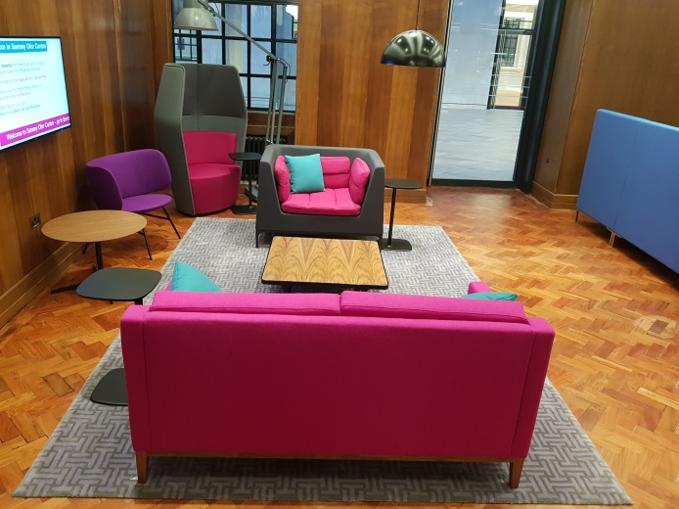
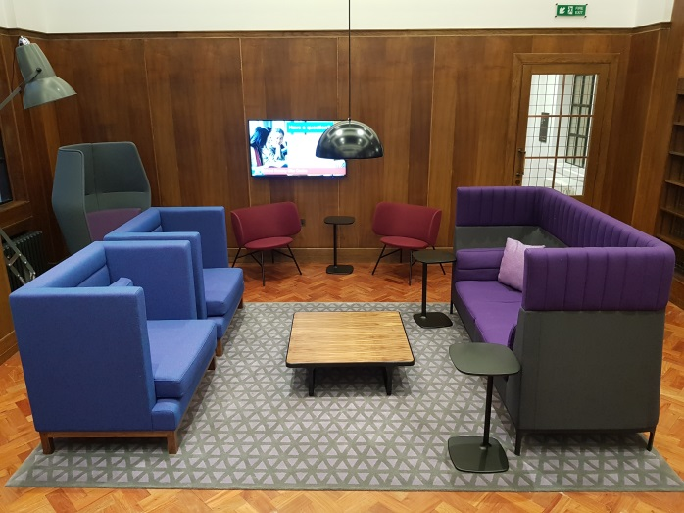
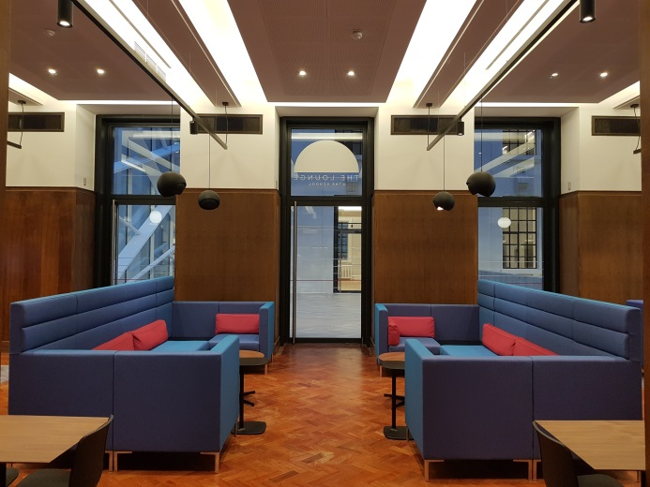
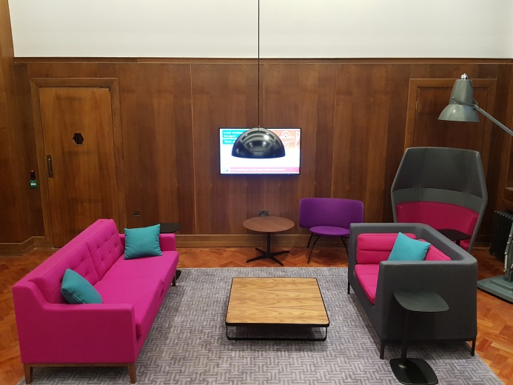
- Chairs and Tables to be arranged horizontally with chairs positioned under tables and benches placed to edge of tables. See examples below.

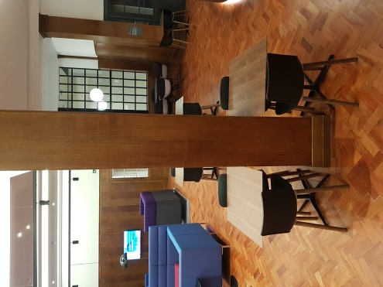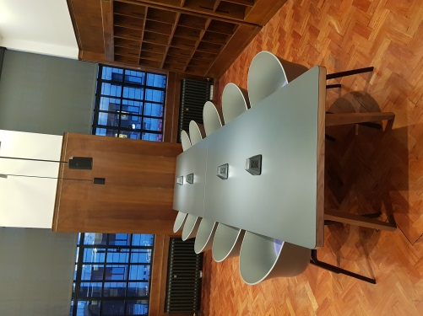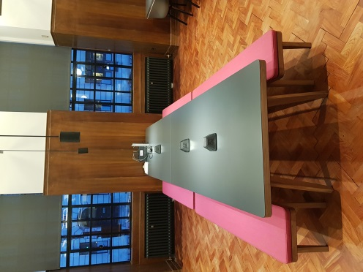
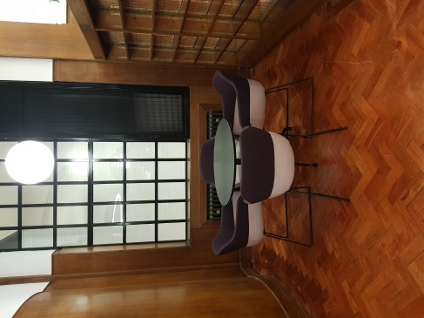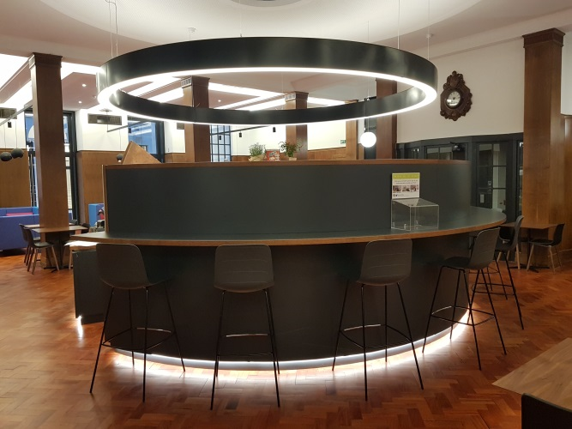

Receptions, Lobbies and Communal Spaces
- Sofas and Armchairs are to be arranged horizontal to the edge of the rug with coffee tables positioned centrally.
- Consider Traffic Flow. One of the most important things to consider when arranging furniture in any room is traffic flow. People should not be tripping over furniture, or each other to pass through the room. Make sure there are a couple of feet (give or take a few inches) between the coffee table and sofa and between chairs. Create a clear path so people can walk from one end of the room to the other without difficulty.
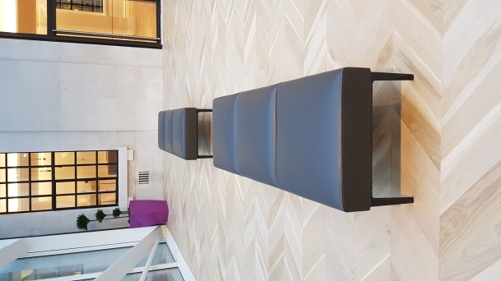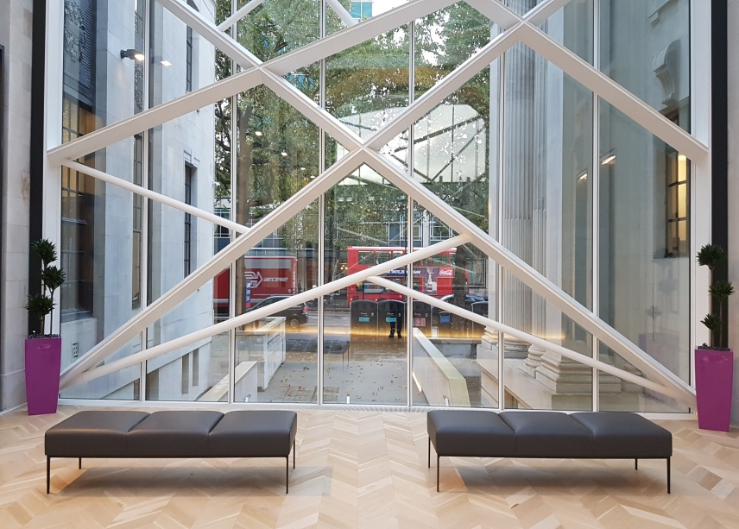

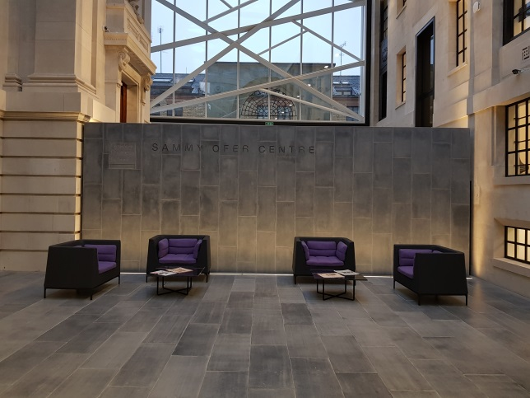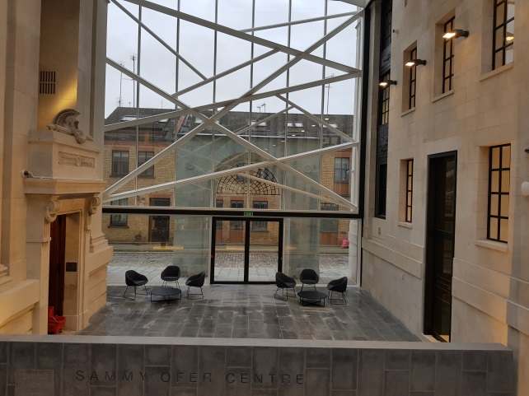
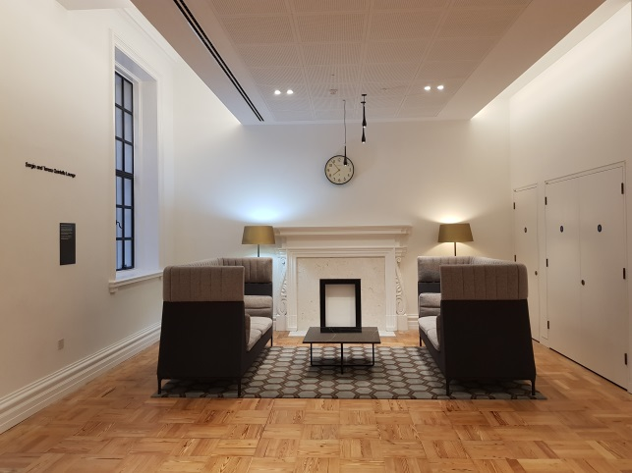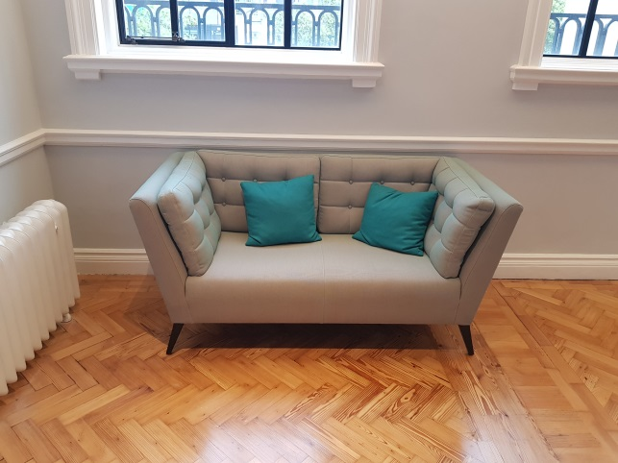

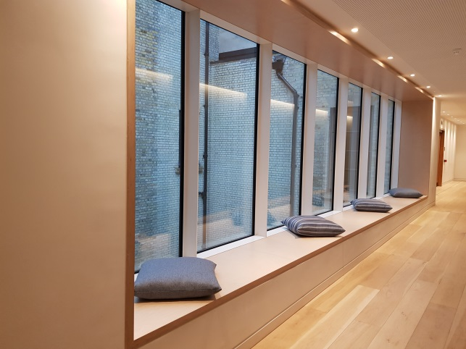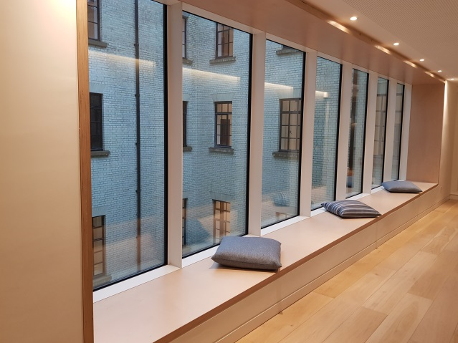

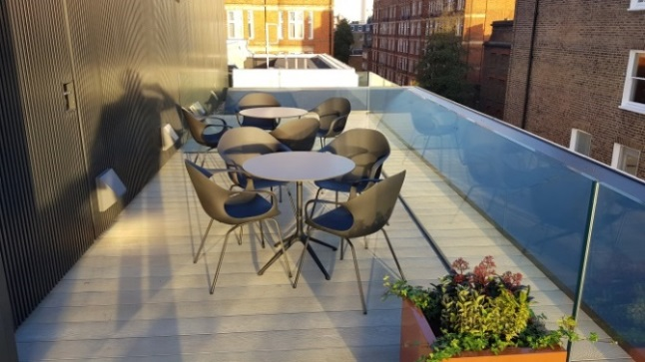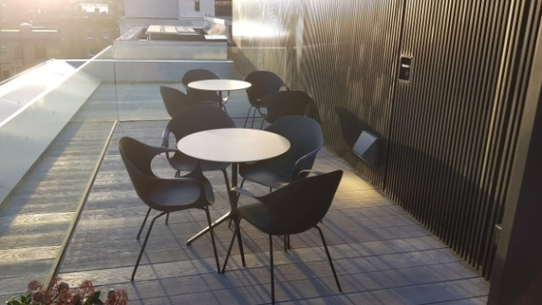

Lecture Theatres, Boardrooms and Seminar Rooms.

- Chairs are to be adjusted and levelled to the highest point with armrests positioned over the desk top. See example below. Where chairs arm are not able to position above the desk top, it then becomes imperative that chairs are kept a small distance from the edge of the worktop to prevent wear and tear to both the chairs as table.
- Chairs and Tables to be arranged with chairs positioned under tables. See example below.
- Consider Traffic Flow. One of the most important things to consider when arranging furniture in any room is traffic flow. People should not be tripping over furniture, or each other, to pass through the Lecture Theatre. Create a clear pathway so people can walk from one end of the row to the other without difficulty.

- Outdated teaching materials are to be removed from the Lecture theatre and teaching rooms upon servicing. All such teaching materials are to be investigated with Team leader before discarded.

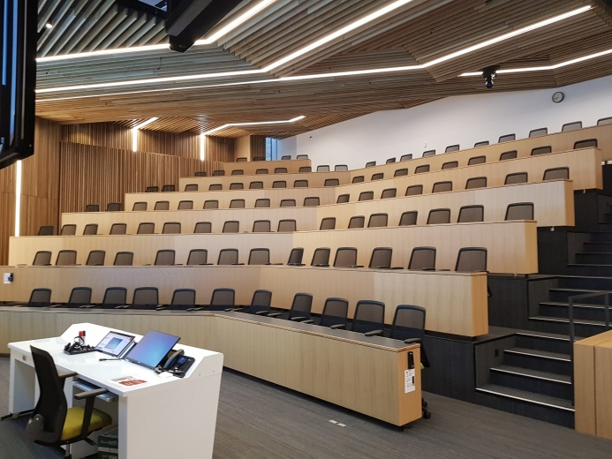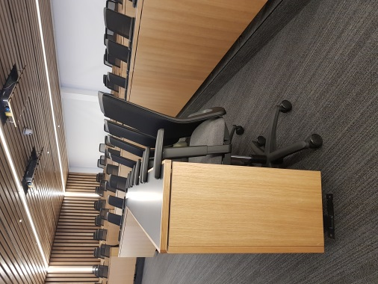

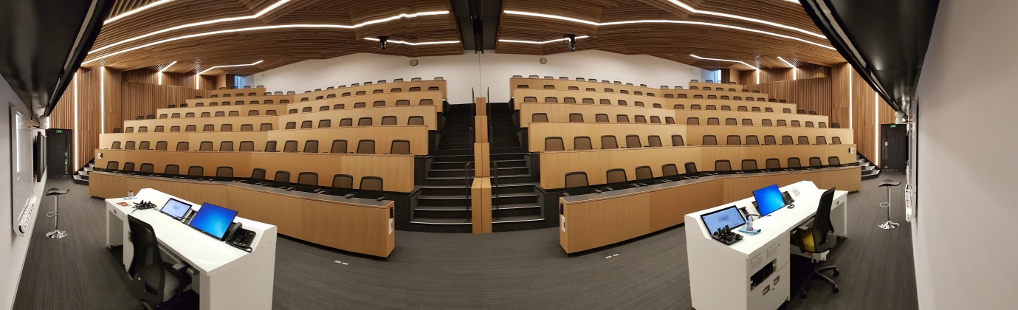

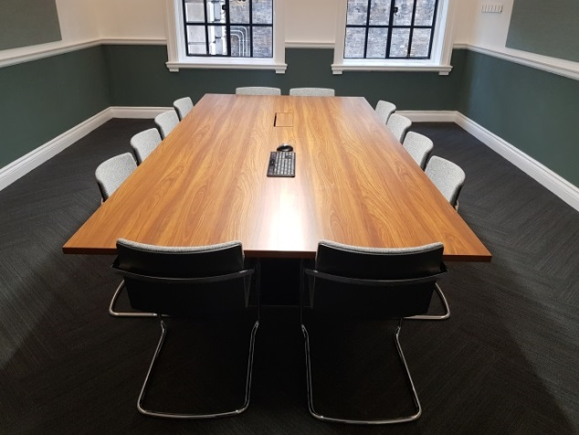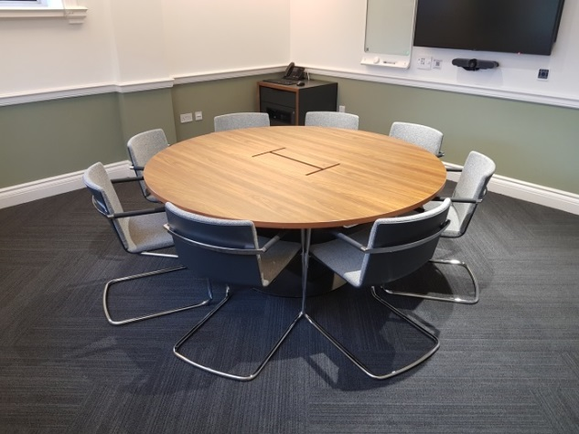
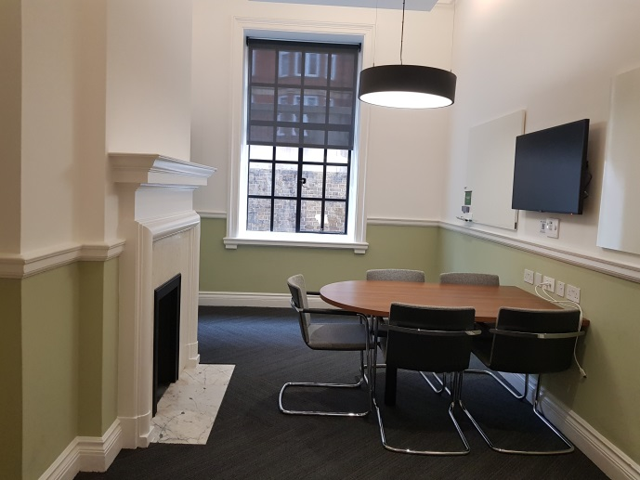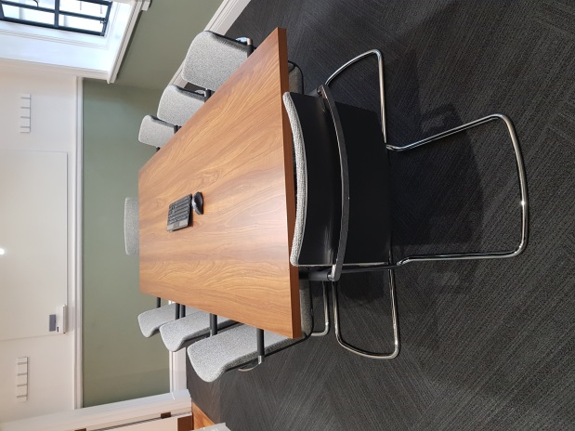
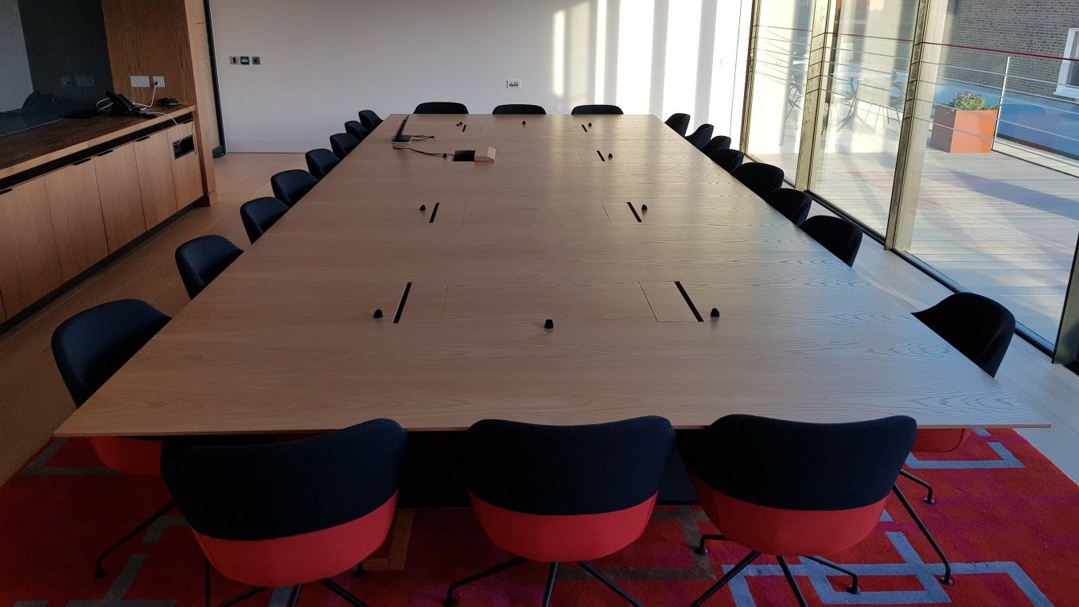

Please email the completed form to the line manager(s) confirming Inspections have been completed in Full, referencing any issues found within the comment boxes. NB: All areas must be set to a high standard.

Name: Victor Hugo Aguirre DATE: 08-02--2019

